Parallel Operation of D.C. Generators

In this tutorial we going to discuss about parallel operation of [DC generators](http://www.electricaledition.com/2015/09/dc-machine-construction-motor-generator.html).We mostly do not go for  parallel operation for DC series generators ,but in some cases like electrical braking we go for it.Before going to deep discussion on **why? parallel operation of DC generators is needed.**

*In latest power generating system, power is usually supplied by many generators connected in parallel because due to lots of advantages.*

[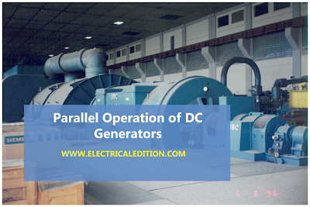](https://2.bp.blogspot.com/-uf_W8PZ3JW4/VsmfR16zOMI/AAAAAAAAA3Y/TwATBFoo2aE/s1600/DC-GENERATOR-PARALLEL-OPEARTION.png)

Advantages of Parallel Operation of DC Generators

The reasons for paralleling D.C. generators, (especially when it is recognized that this usage of the word parallel means duplicator or multiple) are enumerated below

**1. Reliability.**The sources of power such as generators are frequently primary safety items and are therefore duplicated or paralleled for reliability.

**2. Continuity of power supply.** If you are running only single generator,in case of breakdown the supply of power will get disrupted.So to avoid this problem we operate dc generators in parallel.

**3. To improve efficiency of dc generators.**Electrical machines run most efficiently when loaded on their rated capacity. DC generators also runs most efficiently at rated capacity and moreover power costs less per kWh when the generator producing it is efficiently loaded.In parallel operation of dc generators we have one more advantage that we can shutdown/start generator units as per power requirements.

**4. Easy to maintain and repair of DC generators.**Generators requires regular-maintenance and repair as like every machine. In case of parallel operation of dc generators the routine or emergency operations can be performed by isolating the only affected dc generator while load is being supplied by other units. This leads to both safety and economy.

**5. Non-availability of single required large generator.**It is hard to get single rated generator if concern efficiency and cost.So it is better to operate small generators in parallel in order to get desired power.

**6. To increasing plant capacity.** In the modern world of increasing population, the use of electricity is continuously increasing. To increase power capacity as it changes,we have flexibility in parallel operation that is,we can add a new unit   in parallel with the old units.

We have 3 [types of DC generators](http://www.electricaledition.com/2016/01/types-of-dc-machines-dc-generators-dc-motors.html).They are shunt,series,compound dc generators.So let us discuss about,

1.Parallel operation of shunt dc generators

2.Parallel operation of series dc generators

3.Parallel operation of compound dc generators

Conditions:Parallel Operation Of Shunt Generators

Below figure shows a circuit diagram for the parallel operation of two shunt generators. It is assumed that generator A is already operating and supplying a

particular load as per its capacity; that is why the switch SI and the circuit breaker CB, are shown closed in figure.

[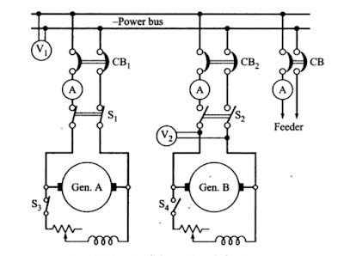](https://3.bp.blogspot.com/-C-0Mau9uvsg/VsmS-DbVziI/AAAAAAAAA2w/Bd4K-MfSN9Y/s1600/dc-shunt-generators-parallel-operation.PNG)

When the load on the station increases beyond the capacity of generator A. it is essential to connect the generator B to operate in parallel with A. in order to share the total load on the station. The procedure for paralleling generator B with generator A comprises following steps.

(i) The prime mover of the generator B is brought up to the rated speed.

(ii) Switch S4 provided in the generator field circuit is closed, as a result the generator will build up its voltage.

(iii) The circuit breaker CB2 is closed.

(iv) The excitation of the generator B is adjusted. so that it generates a voltage equal to the bus bar voltage, that is the reading of voltmeter V2 should be equal to V1

(v) Polarities of the generator B should be the same as those of the bus bars.

(vi) Now the main switch S2 is closed. thus putting generator B in parallel with generator A. However generator B is still running idle or floating (not supplying any load).

(vii) Adjust the field rheostats of generators A and B simultaneously. The field current of generators A should be reduced slowly. while that of generator B be increased. By this process. any amount of load can be shifted on to generator B. However. care should be taken that the incoming machine is not overload.

(viii) In case generator A is to be shut down. the whole load can be shifted onto generator B, provided it has a capacity to supply that load without over- loading. In that case reduce the current in the generator A to zero and then open switch S1.

Next the load sharing by the two generators running in parallel is discussed. Let us assume the following for the derivation of the equations showing the load sharing.

Load Sharing of DC Shunt Generators

Ea emf generated by generator A

Eb emf generated by generator B

V Terminal voltage at the load terminals

Ia Current supplied to the load by generator A

Ib Current supplied to the load by generator B

I Total load current

ra Armature resistance of generator A

rb Armature resistance of generator B

The external characteristic of the two generators can now be expressed as.

V=Ea-Iara ..........(1)

and V =Eb-Ibrb ..........(2)

Total load current, I = Ia + Ib..........(3)

Solving above equations for Ia,Ib

[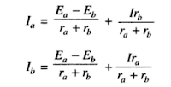](https://1.bp.blogspot.com/-PKpKJR75giY/VsmXdHeBmaI/AAAAAAAAA28/Ca_YjzFT7Q4/s1600/Capture.PNG)

Above equations  clearly indicate that the current supplied by each [generator](http://www.electricaledition.com/2016/02/construction-of-alternator-or-synchronous-generator.html)consists of two components (i) independent of load current (ii) dependent upon load current. First component exists when the generated emfs of two generators running in parallel are different, which certainly causes the circulating current to flow producing heat loss. This component would exist even at no load and can be avoided only when the [emfs generated](http://www.electricaledition.com/2016/01/emf-equation-of-dc-generator.html) by the two generators are equal. Second component shows clearly that the load current divides itself inversely as the [armature resistance of the generators](http://www.electricaledition.com/2016/01/armature-reaction-in-dc-machines.html).

If the load on the generators is a fixed resistance R. Equations ( 1 and 2) can be rewritten as,

Ea=Iara+(Ia + Ib)R  ..........(5)

Eb=Ibrb+(Ia + Ib)R   ..........(6)

Sovling equations (5) & (6)

[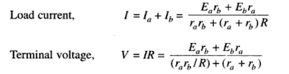](https://4.bp.blogspot.com/-BrdEAgJW3vI/VsmaOMI6AiI/AAAAAAAAA3I/9GDypJ0hq90/s1600/Capture.PNG)

Based on above equations which are obtained by parallel operation of shunt generators we get load shared by each generator operating In parallel can be ascertained depending upon the parameters of the generators.

D.C. Compound Generators in Parallel

Above we discussed why parallel operation of dc generators is necessary ?.Here we are going to discuss about  parallel operation of D.C. compound generators.

Let us have two compound dc generators,say generator 1 and generator 2 running in parallel as shown in the below figure.Assume each generator is taking proper share of load.

[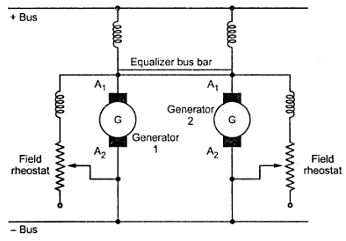](https://1.bp.blogspot.com/-PQL3ZNtpxEc/VsnWd2awFsI/AAAAAAAAA3o/uHfe2OWLuqA/s1600/ccc1126.jpeg)

Due to some reason,say the generator 1 taking more load slightly then the current passing through its series field winding increases strengthening its field to increase the generated e.m.f. This causes generator 1 to take still more load. If system load is assumed to be constant then the load on generator 2 will decrease weakening its series field due to less current passing through its field winding which results in further decrease in its load. This effect is cumulative which leads generator 1 to take the entire load and generator 2 will be driven as motor. The circuit breakers of at least one of the two generators will open to stop the parallel operation. The under compound generators show stable operation like shunt generators.

For stable parallel operation of over and level compound generators, equalizer bus bars are used. It is connected to the armature ends of the series coils of the generators. The equalizer bus bar is also a conductor which is not required is case of under compound generator as their characteristics are not rising.

Now consider that the same two compound generators are operating in parallel with equalizer bar between them. If for any reason, generator 1 starts taking more load than its proper share the its series field current is increased. But now this increased field current will partly pass through series field winding of generator 1 and partly through series field winding of generator 2 via equalizer bar. Thus the two generators are affected in similar way preventing generator 1 from taking extra load. To have proper division of load from no load to full load it is required that the regulation of each generator must be same. The series field resistances should be inversely proportional to the generator ratings.

Brake Test On DC Shunt Motor

In this article we are going to discuss about **brake test on d.c. motor**.Brake test is also a method of finding efficiency of dc motors.We took dc shunt motor as running machine.**Brake test also called as direct loading test** of testing the motor. Because loading will be applied directly on shaft of the motor by means of a belt and pulley arrangement.

**Procedure of Brake Test On DC Shunt Motor**

1. By adjusting the handle of the pulley take different readings of the spring balance.

2. The tension in the belt can be adjusted using the handle. The tension in kg can be obtained from the spring balance readings.

3. Adjusting the load step by step till full load, number of readings can be obtained.By increasing the load is slowly, adjust to get rated load current.

4. The power developed gets wasted against the friction between belt and shaft. Due to the braking action of belt the test is called brake test.

5. The speed can be measured by tachometer. Thus all the motor characteristics can be plotted.

[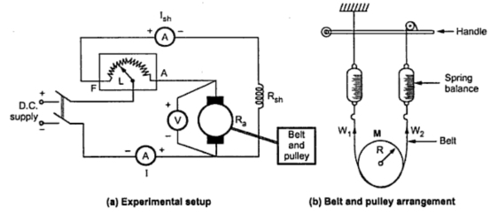](https://1.bp.blogspot.com/-fftBc-wPZWs/Vsn9iCoV2jI/AAAAAAAAA34/s6II6m4CNO0/s1600/brake-test-on-dc-motor.jpeg)

You can refer figure for the experimental setup for performing brake test on a d.c. shunt motor,belt & pulley arrangement mounted on the shaft of the motor.

Calculation Of  Brake Test On DC Shunt Motor

Let           R (or) r= Radius of pulley in meters

               N = Speed in r.p.m.

               W1 = Spring balance reading on tight side in kg

               W2 = Spring balance reading on slack side in kg

So net pull on the belt due to friction at the pulley is the difference between the two spring balance readings.

Net pull on the rope = (W - S) kg  = (W - S) X 9.81 newtons......(1)

As radius R and speed N are known, the shaft torque developed can be obtained as,

Tsh = Net pull X R=(W - S) X 9.81 X R   .....(2)

Hence the output power can be obtained as,Say speed of the pulley is N r.p.m., then,The above equation shows the output power of dc shunt motor in brake test.

  Now let, V = Voltage applied in volts

               I = Total line current drawn in amps.

As we know V,I are input parameters of dc motors in brake test.then,

Pin=V.I Watts  .....(3)

We have output and input.Then why late go and find the efficiency of dc shunt motor.

Efficiency (η)=Output/Input [No units]

From equation (2) & (3)

[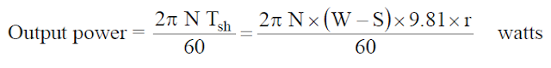](https://1.bp.blogspot.com/-XLPG4nrTrBs/VsoB_OAEBRI/AAAAAAAAA4A/DRH2jPSK8LM/s1600/Capture.PNG)

Advantages Of Brake Test On DC Shunt Motor

1. Actual efficiency of the motor under working conditions can be found out.

2. Brake test is simple and easy to perform.

3. It is not only for dc shunt motor, also can be performed on any type of d.c. motor.

Disadvantages Of Brake Test On DC Shunt Motor

1. In brake test due the belt friction lot of heat will be generated and hence there is large dissipation of energy.

2. Cooling arrangement is necessary to minimize the heat. Mostly in our laboratories we use water as cooling liquid.

3. Convenient only for small rated machines due to limitations regarding heat dissipation arrangements.

4.Power developed gets wasted hence brake test method is little expensive.

5. The efficiency observed is on lower side.

# Swinburne’s Test of DC Machine

[Calculation of Efficiency](https://electricalstudy.sarutech.com/swinburnes-test-of-dc-machine/index.html#Calculation-of-Efficiency)  
[Calculation of Efficiency When the Machine is Motoring on Load](https://electricalstudy.sarutech.com/swinburnes-test-of-dc-machine/index.html#Calculation-of-Efficiency-When-the-Machine-is-Motoring-on-Load)  
[Calculation of Efficiency When the Machine is Generating on Load](https://electricalstudy.sarutech.com/swinburnes-test-of-dc-machine/index.html#Calculation-of-Efficiency-When-the-Machine-is-Generating-on-Load)  
[Advantages of Swinburne's Test](https://electricalstudy.sarutech.com/swinburnes-test-of-dc-machine/index.html#Advantages-of-Swinburne's-Test)  
[• Disadvantages](https://electricalstudy.sarutech.com/swinburnes-test-of-dc-machine/index.html#Disadvantages-of-Swinburne's-Test)

This method is an indirect method of testing a dc machine. It is named after Sir James Swinburne. Swinburne's test is the most commonly used and simplest method of testing of shunt and compound wound dc machines which have constant flux. In this test the efficiency of the machine at any load is pre-determined. We can run the machine as a motor or as a generator. In this method of testing no load losses are measured separately and eventually we can determine the efficiency.

The circuit connection for Swinburne's test is shown in figure below. The speed of the machine is adjusted to the rated speed with the help of the shunt regulator R as shown in figure.

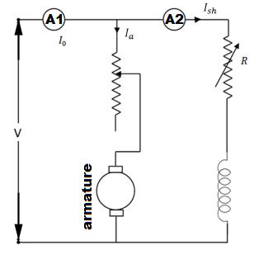

*Connection Diagram of Swinburne's Test*

### Calculation of Efficiency

Let, I0 is the no load current ( it can be measured by ammeter A1 )

Ish is the shunt field [electric current](https://electricalstudy.sarutech.com/electric-current-and-theory-of-electricity/index.html) ( it can be measured by ammeter A2 )

Then, no load armature [electric current](https://electricalstudy.sarutech.com/electric-current-and-theory-of-electricity/index.html) = (I0 - Ish)

Also let, V is the supply voltage. Therefore, No load power input = VI0 watts.

In Swinburne's test no load power input is only required to supply the losses. The losses occur in the machine mainly are:  
Iron losses in the core  
Friction and windings losses  
Armature copper loss.

Since the no load mechanical output of the machine is zero in Swinburne's test, the no load input power is only used to supply the losses.

The value of armature copper loss = (I0 - Ish)2 Ra

Here, Ra is the armature [resistance](https://electricalstudy.sarutech.com/electrical-resistance-and-laws-of-resistance/index.html).

Now, no to get the constant losses we have to subtract the armature copper loss from the no load power input.

Then, Constant losses WC = VI0 -(I0 - Ish)2 Ra

After calculating the no load constant losses now we can determine the efficiency at any load.

Let, I is the load current at which we have to calculate the efficiency of the machine.

Then, armature [electric current](https://electricalstudy.sarutech.com/electric-current-and-theory-of-electricity/index.html) (Ia) will be (I - Ish), when the machine is motoring.

And Ia = (I + Ish), when the machine is generating.

#### Calculation of Efficiency When the Machine is Motoring on Load

Power input = VI

Armature copper loss, PCU = I2 Ra = (I - Ish)2Ra

Constant losses, WC = VI0 -(I0 - Ish)2 Ra

Total losses = PCU + WC  
∴ Efficiency of the motor:  
\eta_m\;=\;\frac{output}{input}\;  = \;\frac{input\;-\;losses}{input}\;=\;\frac{VI\;-\;(P_CU + W_C)}{VI}

#### Calculation of Efficiency When the Machine is Generating on Load

Power input = VI

Armature copper loss, PCU = I2 Ra = (I + Ish)2 Ra

Constant losses, WC = VI0 - (I0 - Ish)2 Ra

Total losses = PCU + WC  
∴ Efficiency of the generator:  
\eta_g\;=\;\frac{output}{input}\;=\;\frac{input\;-\;losses}{input}\;=\;\frac{VI\;-\;(P_CU\;+\;W_C)}{VI}

### Advantages of Swinburne's Test

The main advantages of this test are :

1. This test is very convenient and economical as it is required very less power from supply to perform the test.
2. Since constant losses are known, efficiency of Swinburne's test can be pre-determined at any load.

### Disadvantages of Swinburne's Test

The main disadvantages of this test are :

1. Iron loss is neglected though there is change in iron loss from no load to full load due to armature reaction.

2. We cannot be sure about the satisfactory commutation on loaded condition because the test is done on no-load.

3. We can’t measure the temperature rise when the machine is loaded. Power losses can vary with the temperature.

4. In [dc series motors](https://electricalstudy.sarutech.com/series-wound-dc-motor-or-dc-series-motor/index.html), the Swinburne’s test cannot be done to find its efficiency as it is a no load test.

Hopkinson's Test or Regenerative Test On DC Motor

In the previous post we have seen how to determine the efficiency of DC machines using [brake test](http://www.electricaledition.com/2016/02/brake-test-on-dc-shunt-motor.html). **Hopkinson's test** is also a test of finding  the efficiency of a dc motor. **Hopkinson's test or regenerative test** is a full load test and it requires two identical machines which are coupled to each other.In this test two identical d.c. machines mechanically coupled to each other and simultaneously tested.One is operated as generator another one as motor,hence we can find efficiency of two [dc machines](http://www.electricaledition.com/2015/09/dc-machine-construction-motor-generator.html) simultaneously.So output power of dc machines are going to be wasted.The mechanical output of motor given to [generator](http://www.electricaledition.com/2016/01/dc-generator-working-principle.html) through shaft to shaft mechanical coupling.And generator's electrical power supplied to run the motor,where losses will be supplied by external power source.

If there are no losses in the motor-generator set,the electrical power from the generator and mechanical output from motor are enough to run motor,generator respectively.So no need of any external power supply to the motor.But due to losses, the [generator](http://www.electricaledition.com/2016/01/dc-generator-working-principle.html) output is not sufficient to drive the motor. Thus motor takes current from the supply to account for losses.

Observe circuit diagram of **Hopikinson's test**. The [two shunt dc machines](http://www.electricaledition.com/2016/02/parallel-operation-of-dc-generators.html) are connected in parallel. In that two machines,one is started as a motor another one operated as generator.Here the only rotor connections are mentioned,stator connections are not shown for simplicity.

Connection Diagram of Hopkinson's Test

[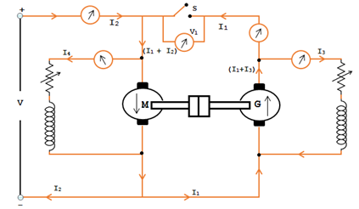](https://3.bp.blogspot.com/-f0ZbCeqoR1U/VsraUXCbQ6I/AAAAAAAAA4c/VsnIeySyp_E/s1600/brake-test-on-dc-machines.jpeg)

First switch S is kept open. The other machine which is coupled to first will act as load on first which is acting as motor. Thus second machine will act as a generator.With the help of field rheostat speed of the motor is adjusted to normal value.Note down the observed voltmeter readings.With the help of generator field rheostat voltage of the generator is adjusted up to voltmeter reading is zero.This is to make sure generator voltage is having same magnitude and polarity of that of supply voltage.By making this we can prevent heavy circulating current flowing in the local loop of armatures on closing the switch.

Now close the switch S. The two machines can be put into any load by adjusting their field rheostats. The generator current I2 can be adjusted to any value by increasing the excitation of generator or by reducing the excitation of motor. The various reading shown by different ammeters are noted for further calculations.

The input to the motor is nothing but the output of the generator and small power taken from supply. The mechanical output given by motor after supplying losses will in turn drive the generator.

Calculation of Efficiency by Hopkinson's Test

Let V = Supply voltage

Motor power Input = V(I1 + I2)

Generator power Input = VI1 

We can determine the efficiency of DC machines in two cases.

**Case 1:**  *Assuming that the efficiency of both the machines are same.*

**Case 2:**  *Assuming both the machines has same iron loss, friction loss and windage loss.*

**Case 1:**

**Assuming that the efficiency of both the machines are same.**

Motor output power = η x Motor Input power

                           = η V(I1+I2)

i.e., Motor Input power = Generator Input

Now the Generator output = η x generator Input

= η x ηV(I1 +I2)

= η2 V(I1+I2)

VI1 = η2V(I1+I2)

∵ Generator output η = **√** {I1 / (I1+I2)}

**Note:** The above expression is used to determine the efficiency satisfactorily perfect for a rough test. If case need to find more accuracy then the efficiency of the two machines can be determined separately using the below expressions.

**Case 2:**

**Assuming both the machines has same iron loss, friction loss and windage loss.**

However the iron loss, friction loss and windage loss of both the machines will be same due to both the machines are identical. On this notion we can find the efficiency of each machine.

It is not necessary to assume that the efficiency of both the machines are same. It is due to that both the DC machines don’t have the same armature winding and the field winding.

Let,

Ra = Armature winding resistance of individual machines.

I3 = Shunt field current Generator G

I4 = Shunt fief current of Motor M

Generator armature copper loss = (I1+I32) Ra

Motor armature copper loss = (I1 + I2 – I42) Ra

Shunt field copper loss in G = VI3

Shunt field copper loss in M = VI4

Power drawn from the DC source is VI2 and is equal to the total losses of motor and generator.

VI2 = Motor and Generator total losses

To get the iron loss, friction and windage loss subtract the armature copper loss and shunt copper loss of both the machine from VI2.

Total losses of 2 machines (M & G)

   = VI2 – [(I1+I3)2Ra + (I1+I2-I42Ra+VI3+VI4)] = W

To find the individual machine losses divide by 2

i.e. Total losses of each machine = W/2

**To find the efficiency of Motor in hopkinson's test**

Input motor power = V(I1 + I2)

Total Losses = (I1+I2-I42)Ra + VI4 + (W/2)

= Wm

Efficiency of Motor ηm = (Input – Losses) / Input

=**[V(I1+I2) – Wm] / [V(I1+I2)]**

**To find the efficiency of Generator in hopkinson's test**

Generator output power = VI1

Total Losses = (W/2) + (I1+I32)Ra + VI3

                   = Wg

Efficiency of Generator **ηg = VI1 / (VI1+Wg)**

Advantages of Hopkinson's Test or Regenerative Test On DC Motor

The various merits of Hopkinson's test are,

1. This test is very economical because it requires only very small power just to compensate the losses which is very small value when compared to full-load power of the motor-generator coupled system.  
  
2. This is performed at full load condition so we can take flux distortion into account.  
  
3. There is no need for arranging any actual load. Similarly by changing the field currents of two machines, the load can be easily changed and a load test over complete range of load can be taken.  
4. This test is better suited in case of large machines.

Disadvantages of Hopkinson's Test or Regenerative Test On DC Motor

The various demerits of Hopkinson's test are,

1. It is a big task to check for two identical machines needed for Hopkinson's test.  
     
   2. We can not load two machines equally all the time.  
     
   3. It is not possible to get separate iron losses for the two machines though they are different because of their excitation.  
     
   4. It is difficult to operate the machines at rated speed because field currents vary widely.  
     
   5.The machines are not loaded equally in case of small machines which may lead to difficulty in analysis.

Retardation Test or Running Down on D.C Machines

In the previous articles we have seen [brake test](http://www.electricaledition.com/2016/02/brake-test-on-dc-shunt-motor.html),[hopkinson's-test](http://www.electricaledition.com/2016/02/hopkinsons-test-on-dc-machines.html) which are essential to find out dc machine efficiency.Now in this article we are going to discuss about **retardation test on dc machines**.Retardation test is also called as running down test.This is very efficient way to find out stray losses in dc shunt motors.In this test we get total stray losses nothing but combination of mechanical (friction & windage) and iron losses of the machine.

The circuit diagram of retardation test on dc machines shown below.A1,A2 are armature terminals.

[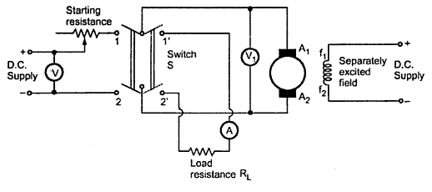](https://4.bp.blogspot.com/-KQpUrYfSqN0/Vsw2TCaVNFI/AAAAAAAAA4w/3txyaF9F3Fw/s1600/retardation-test-on-dc-machines.jpeg)

Procedure of Retardation Test on D.C Machines

The main points in the retardation or running down test are discussed below,

1. Now start the dc machine normally,run the machine slightly above the rated speed by adjusting resistance.  
2. After achieving above the rated speed just cutoff the power supply to the armature,but keeping field normally excited.  
3. Now wait for some time to fall down of speed below rated,then using the tachometer note down the values of speed (in rpm) and time (in sec).  
4. The armature consequently slows down and the amount of kinetic energy present in the armature is used to supply the rotational or stray losses which includes iron, friction and winding loss.

If I is the amount of inertia of the armature ans is the angular velocity.

Kinetic energy of armature = 0.5 Iω².

Rotational losses, W = Rate of change of kinetic energy.

[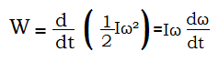](https://2.bp.blogspot.com/--YTP89Y-tJU/Vsw4X9jOPaI/AAAAAAAAA5E/ci9up_3RO40/s1600/Untitled.png)

I=Moment of inertia of the armature.

In retardation test of dc machines, the rotational losses are given by

[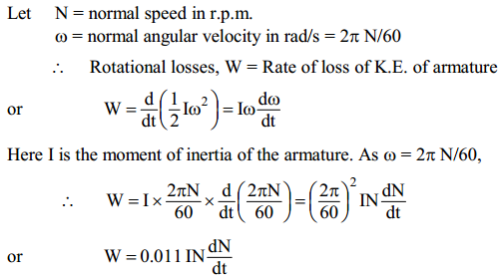](https://1.bp.blogspot.com/-aUOQiQziBw0/Vsw43SY06CI/AAAAAAAAA5I/Bt9Y4ZsTV8E/s1600/rtrdatntst.PNG)

We have the formula of stray losses in retardation test of machines,but here moment of inertia (I) of the armature is unknown.To find out I we have two different methods.We need to find dN/dt too.

Determination of dN/dt in retardation test of dc machines

The voltmeter (V1) across the armature will give the value of back e.m.f. of the motor. We know that back e.m.f. is proportional to speed so that we calibrate the  voltmeter  to show the speed reading directly.

[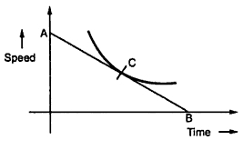](https://4.bp.blogspot.com/-z6gRfpEDMgE/Vsw7LkKl13I/AAAAAAAAA5Y/_vjBtS74gK8/s1600/curve.jpeg)

When motor is cut off from the supply, the speed decrease in speed is noted with the help of stop watch.You can observe curve drawn between calibrated values of time and speed.

At any point C corresponding to normal speed, a tangent AB is drawn. Then the value obtained from below can be substituted in the expression for W which can give the rotational looses.

dN/dt=OA(in rpm)/OB(in seconds)

Methods of finding moment of inertia (I) in retardation test

(a) Using Flywheel

(b) Without using Flywheel

(a) Using Flywheel in retardation test

In this method we use the fly wheel whose moment of inertia is I1 to find the I value. In first case retardation test is performed with armature alone and dN/dt1 is determined. In next case,flywheel is employed on the shaft,change in speed, dN/dt2 is noted.Addition of fly-wheel will not materially affect the rotational losses.

[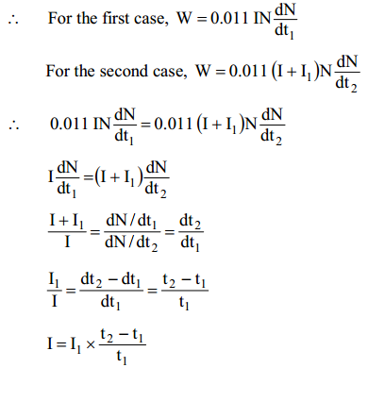](https://4.bp.blogspot.com/-JkBaC2p_zcs/Vsw-DtTv07I/AAAAAAAAA5k/XhBzgytVIyc/s1600/rtrdtn2.PNG)

Since the values of I1,   t1  and   t2 are known, the moment of inertia I of the

armature can be determined.

(b) Without using Flywheel in retardation test

Without using flywheel, I is eliminated from the expression by an experiment. First, retardation test is performed with armature alone. The rotational losses are given by;

      W = 0.011 IN dN/dt1

Next the motor is loaded with a known amount of power W' with a brake. For

the same change in speed, dN/dt2 is noted. Then,

[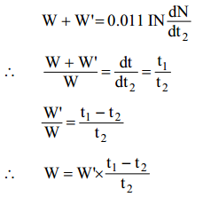](https://4.bp.blogspot.com/-xLfObL_VVS4/Vsw-zc3ju8I/AAAAAAAAA5s/qocmJdcfqPw/s1600/rtrdtn3.PNG)

Since the values of W', t1 and t2 are known, the value of W can be determined.

The electric loading in retardation test W' (or extra power loss) is given by;

W' = average voltage x average current = V' I'a.

This is the simple article on **retardation test on dc machines.**In the nest post we try to share a pdf on retardation test lab manual.